第二届“认证杯”数学中国
数学建模国际赛
承 诺 书

我们仔细阅读了第二届“认证杯”数学中国数学建模国际赛的竞赛规则。
我们完全明白，在竞赛开始后参赛队员不能以任何方式（包括电话、电子邮件、网上咨询等）与队外的任何人（包括指导教师）研究、讨论与赛题有关的问题。
我们知道，抄袭别人的成果是违反竞赛规则的, 如果引用别人的成果或其他公开的资料（包括网上查到的资料），必须按照规定的参考文献的表述方式在正文引用处和参考文献中明确列出。
我们郑重承诺，严格遵守竞赛规则，以保证竞赛的公正、公平性。如有违反竞赛规则的行为，我们将受到严肃处理。
我们允许数学中国网站(www.madio.net)公布论文，以供网友之间学习交流，数学中国网站以非商业目的的论文交流不需要提前取得我们的同意。
我们的参赛队号为：
我们选择的题目是：
参赛队员 (签名) ：1215
队员1：张娜

队员2：李佳酿

队员3：盛小敏

参赛队教练员 (签名)： 单广荣

第二届“认证杯”数学中国
数学建模国际赛
编 号 专 用 页

参赛队伍的参赛队号：（请各个参赛队提前填写好）：

#1215

竞赛统一编号（由竞赛组委会送至评委团前编号）：

竞赛评阅编号（由竞赛评委团评阅前进行编号）：

TITLE
Abstract: This article refers to an example of the hermit crab allocation of resources in order, by waiting for the exchange to reflect the number of housing vacancy chain length on economics , the use of this efficient allocation can be applied to apartments, cars, jobs aspect .Jobs in the enterprise , and achieving through the exchange of vacancy chain model strategy, both can make only the best employees in positions to play their own strengths , but also further improve the employment rate , but also to corporate resources can be fully utilization , the development of optimal efficiency .
In one model , through the establishment of vacancy chain model , based on past employee turnover , the transition probability matrix solving jobs and job transfer matrix multiplier ultimately determine the average length of vacancy chains M,In other words, a job can mean that the whole of human resources M jobs , the employment rate in the past on the basis of improved ,by calculation, obtained M = 3.85, of course, this model is not to be fully applied to all industries , the paper also shows that some of these conditions .
In the second model , the province through the human resource needs and job vacancies in all sectors , how many people should find a professional to meet employees and employers .On the basis of the above vacancy chains , we have established a Markov model, applied probability theory of Markov chain analysis to study changes of the economic data , the use of dynamic Markov model prediction of human resources , predict business the recent years of human resources , in order to predict the expense of human resources corporate customers in recent years .

Key words: vacancy chains Markov chain employment rate
HR expends dynamic prediction

Contents

1. The Description of Problem…...........................................................................................................5
2. The Description of symbol................................................................................................................. 6
3. Base on the “vacancy chain ”to allocation H..........................................................................6 3.1 Establish transfer matrix position....................................................................................................6
3.1.1 establish“vacancy chain” model.....................................................................................7
3.1.2 Calculation of job transition probability matrix......................................................7
3.1.3 Jobs multiplier to calculate the transfer matrix.......................................................8
3.1.4Vacancy chain length.............................................................................................................9
3.1.5Model analysis and results.................................................................................................10
3.2 Human resource allocation model for the exchange of vacancy chain impact........13
3.2.1 Exchange of the job questions raised..........................................................................13
3.2.2 Work to solve the problem of the job exchange....................................................13
4. Markov model -based human resource planning and forecasting...........................14
4.1 Human resources to meet the conditions and solving.....................................................14
4.2 Construction of Markov model...................................................................................................17
4.2.1 The basic model of Markov..............................................................................................17
4.2.2 Transition probability is determined.............................................................................18
4.2.3 Determination of Markoff probability matrix..........................................................20
4.2.4 To build the model, to predict.................................................................................. .......20
4.2.5 Human Resources annual cost forecasting model................................................21
4.2.5.1 Recruitment costs............................................................................................................21 4.2.5.2Training costs , staff salaries and various benefits expense.....................................21
4.2.5.3 Social insurance and other related expenses...................................................21
4.2.5.4Total annual cost of human resources..................................................................22
5.2.6Model analysis and results.................................................................................................22
5. Summary.....................................................................................................................................................24
6. References....................................................................................................................................................25
7. Appendix......................................................................................................................................................25

I. The Description of the Problem
Hermit crabs—which are the most popular pet variety in the United States—depend on other creatures' shells for protection. Strip a hermit crab of its shell and you will see its soft, pink abdomen curled behind its head like a fern's frond. Most hermit crabs favor snail shells, although some use the shells of bivalves, like clams and scallops, and others have made do with driftwood, stones and pieces of glass or plastic bottles.
When a lone crab encountered one of the beautiful new shells, it immediately inspected the shelter with its legs and antennae and scooted out of its current home to try on the new shelter for size. If the new shell was a good fit, the crab claimed it. Classic hermit crab behavior. But if the new shell was too big, the crab did not scuttle away disappointed instead, it stood by its discovery for anywhere between 15 minutes and 8 hours, waiting. This was unusual.Eventually other crabs showed up, each one trying on the shell. If the shell was also too big for the newcomers, they hung around too, sometimes forming groups as large as 20. The crabs did not gather in a random arrangement,however. Rather, they clamped onto one another in a conga line stretching from the largest to smallest animal—a behavior the biologists dubbed "piggybacking." As soon as a crab claimed its new home, all the crabs in queue swiftly exchanged shells in sequence. The largest crab at the front of the line seized the crab's abandoned shell. The second largest crab stole into the first's old shell. And so on. Hermit crabs really have to think about and evaluate these shell resources—these are life and death decisions, They're interesting to look at from that perspective. They have greater than average crab Intelligence.
Sociologists and economists use the term “vacancy chain” to describe a sequential exchange of resources that benefits every individual in the sequence. vacancy chains are an excellent way to distribute resources: Unlike More typical competition,a single vacancy chain benefits everyone involved—each individual gets an upgrade. So it makes sense that hermit crabs have evolved sophisticated social behaviors to make the most of vacancy chains. Studying how these animals behave may help us improve how we distribute resources—such as apartments, cars and jobs—among ourselves.
Goals of your model:
1. Evolve social strategies to exchange jobs in queue so that everyone benefits.Can we apply them to all industries? If not, what conditions need to meet?
2. Now a new Human Resource website want to adopt your idea, How many job applicants do need to satisfy both employers and employees. Run your model to predict the change of HR expends for some enterprise customers within the next five years.
In addition to your formatted solution, prepare a one to two page advertising sheet for the website highlighting your strategies and results.

II.The Description of symbol
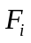: Number of the class i job positions disappear（such as :recruitment of new employees，Certain factors to withdraw jobs and so on）；
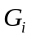: Added number of the market segments’jobs of the class i jobs (such as : to find a more higher salary, employees abandon their job)；
N: Number of job positions；
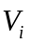: Added number of the class i job position segments’jobs;
: The probability of the transfer from the class i job position segments’jobs to the class j job position segments’jobs;
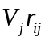: The total flow that transfer from the class j job position segments’jobs to the class i job position segments’jobs, also means the total flow that transfer from the class i job position
segments’jobs to the class j job position segments’jobs.
X: The total number of job seekers
Y: The total number of staff needs
Z: The number of remaining staff
δ: The number of staff required to exchange
III. Base on the “vacancy chain ”to allocation HR
3.1 Establish“vacancy chain” model
With the development of society, the allocation and management of HR is particularly important, in order to model the exchange of resources to meet the interests of the individuals one by one , you can achieve better resource allocation or better meet people's employment situation . Therefore , we have established the “ vacancy chain ”model, using assigned jobs in queue, so that more staff can find the most suitable job , and thus increase social employment rate.
3.1 .1 Establish transfer matrix position
The transfer of job process means the formation of new position, which makes all kinds of employees regularly transfer from a type of job or a lower-level job to another type of job or another higher -level job positions.Therefore, the transfer process includes jobs between different levels of staff , as well as the process of inflow and outflow of employees . Therefore, the work transfer matrix including the number of jobs in the transfer matrix and matrix inflow of new employees . As shown in Table 1:
Table 1: Job transfer matrix architecture table
Job transfer out of place  Job  Transfer  in of place | job position segments  i,……,j | Disappear factors of job position  s,……,j | total
job position segments  i,……,j | Job position transfer matrix  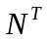 | Jobs disappear matrix  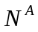 | n

3.1.2 Calculation of job transition probability matrix
Within enterprises, according to different classification standards jobs can be classified into different level of job position segments.Throughout the enterprise, added quantity is equal to the number of new employees into new jobs, corporate jobs among the various work positions within the total transfer amount is equal to the total amount transferred to jobs and enterprises in a state of dynamic equilibrium.You can use formula (1), (2) Description:
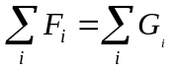 i=1,2,3,4……N (1)
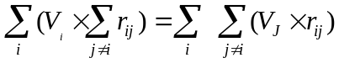 (2)
If any work considered separately sub job i, the number of new jobs plus transfers from other sub- jobs to work i work into several sub- jobs jobs , equivalent to the number of working sub- jobs disappear plus jobs by this sub- market to other the number of revolutions of the sub- market. Expressed by the formula :
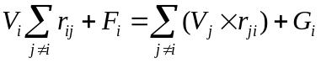 i=1,2,3……,N (3)
Assuming 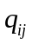 on behalf of the vacancy transition probability , which from i sub- jobs to sub j positions , can be calculated by Equation 4results:
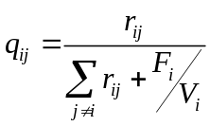 (4)
To express the transition probability of various positions with matrix , came to work transition probability matrix Q={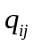}. Job transition probability matrix shows the configuration of the relationship between the positions swapped engineering jobs once the transition probability, describing a period between jobs at all levels turn into a phenomenon , draw job mobility within the enterprise work. By job transition probability matrix can be further calculated shift jobs multiplier matrix.
3.1.3 Jobs multiplier to calculate the transfer matrix
Equation 4 Q matrix represents the sub- post jobs directly transferred from i to j sub post a transfer matrix , on behalf of a job transfer , and in the reality of companies in the enterprise operation cycle , a job to go through multiple transfers , and rational deployment of human resources positions require multiple transfers .Therefore, if the vacancy 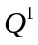 on behalf of direct transfer from i to j grade level job positions in a transition probability matrix , 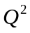representing the transition from i -level job vacancy via k to j -level post secondary transition probability matrix , and so on , all the possible the total transition probability is obtained after adding Markov work shift multiplier matrix (M).The Markov matrix multiplier column sum , get the length of the vacancy chains , which represents work from any level jobs until entering and leaving the enterprise transition probabilities .Thus , the transfer of work on behalf of the elements of the matrix multiplier jobs into sub- positions from i , j sub post will go through the total number of transfers before leaving the company, or so-called transition probabilities and .When jobs move from one level to another level jobs i work j, this process involves the transfer by a secondary transfer , plus three times the total transfer ... etc. , so from work transition probability matrix Q, to calculate the work transfer multiplier matrix M, using the following formula :
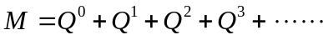
When the transfer unlimited number of trends can be changed as shown in Equation 5. This also can be inferred , job transfer matrix multiplier matrix by an inverse matrix calculation and job transition probability matrix obtained :
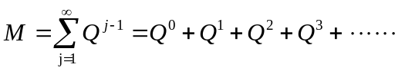
therefore，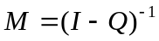 (5)

3.1.4 Vacancy chain length
Vacancy chain length M i used to analyze the number of job vacancies because of a job vacancy supply chain for the entire shift employees to offer.For example , M1 represents a level of vacancies Part I provides an opportunity for M1 jobs overall staff .If M1, M2, M3 medium , M1>M2>M3, it means that I-Level jobs by filtration , can bring more jobs for the entire labor market choices , the actual ability to form stronger job supply .Reflected in the aspects of improving employment policy means,in the case of normal operation of the industry, providing a level 1 job , not only to provide employment opportunities for the level of competent personnel , but also by the post filter to provide advancement opportunities for other grades competent personnel indirectly , thus providing the lowest level jobs , thus greatly improving the employment rate.The longer the vacancy chain length , which means more jobs in the corporate transfer times , can provide more employment opportunities for housing for staff of different abilities , job filtering phenomenon is more obvious.Therefore, we can analyze the size of different levels of job vacancy chain length by observing an enterprise vacancy chain length, and compared to determine which jobs to provide employment opportunities for a significant degree .

Table 2 Work transition probability matrix
Job transfer out of place  Job  Transfer  in of place | Level 1 jobs  position | Level 1 jobs  position | Level 1 jobs  position | the probability of Job position disappear
Level 1 jobs  position | 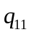 | 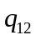 | 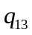 | 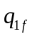
Level 1 jobs  position | 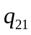 | 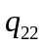 | 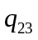 | 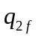
Level 1 jobs  position | 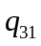 | 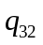 | 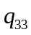 | 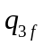

Table 3 Job transfer matrix multiplier
Job transfer out of place  Job  Transfer  in of place | Level 1 jobs  position | Level 2 jobs  position | Level 3 jobs  position | Vacancy chain length | The average length
Level 1 jobs  position | 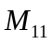 | 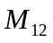 | 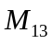 | 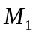 | 
Level 2 jobs  position | 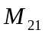 | 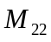 | 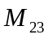 | 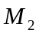
Level 3 jobs  position | 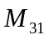 | 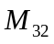 | 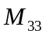 | 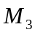

According to a simple analysis of Tables 2 and 3 , we can see that a job can mean that the whole of human resources M jobs , that was only one person can have a job, and now M individuals can find work, rather in the employment rate in the past on the basis of improved 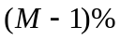.Thus the employment pressure on society to achieve a big relief. This advantage is our established model lies.
3.1.5 Model analysis and results
The following table is a production enterprise personnel divided into several levels according to the level of job and salary , and each level of inflows and outflows of its staff , senior -level officials said the plant , plant officials said two administrators , plant officials said the technical staff three , four staff member said the bottom ( of the class technology live relatively small, so the flow of more ) , so the inflow and outflow of more, it is very realistic .
Table 4 A company 's job flow diagram
Job position | November 2012 | November 2013 | in inflow | outflow
 | Number of Employees
First level employee | 9 | 10 | 2 | 1
second level employee | 31 | 38 | 11 | 5
third level employee | 132 | 149 | 43 | 26
Forth level employee | 281 | 343 | 99 | 37

the senior level staff signify the engineer,the second level staff signify the factory manager , the third level staff signify the factory technicians , and the forth level staff signify bottom ( of the class technology less, so the flow of more ) , Therefore, the inflow and outflow more, it is very realistic .Relatively low due to the professional staff job work experience , with the passage of time, the work has been difficult to filter low-level jobs to work more experienced staff to do so for the rich work experience, and job and has been very very low difficult to meet the demand, so the corresponding transition probability is large.
Thus we get it to work transition probability calculation results ( Table 5 )
Table 5 Thus we get it to work transition probability calculation results
Job transfer out of place  Job  Transfer  in of place | Level 1 jobs  position | Level 2 jobs  position | Level 3 jobs  position | Level 4jobs  position | the probability of Job position disappear
Level 1 jobs  position | 0.667 | 0.083 | 0 | 0 | 0.250
Level 2 jobs  position | 0.024 | 0.647 | 0.078 | 0 | 0.207
Level 3 jobs  position | 0 | 0.065 | 0.625 | 0.052 | 0.258
Level 4 jobs  position | 0 | 0 | 0.109 | 0.606 | 0.285

Can be read from Table 5, the disappearance of the probability level of 25% of jobs ,In the vacancy chain theory , Level 1 jobs Position there are other jobs to shift personnel , the figure also has data show that the number of jobs has also increased level , so the job is able to shift to higher positions , and can also increase .
So the above table and the above analysis, we can get the job transfer matrix multiplier calculation results table:Job transition probability matrix calculations represent only a transfer of jobs , so many times from the previous formula can transfer multiplier matrix M ( Table 6 ) .
Table 6 Shift jobs multiplier matrix calculations
Job transfer out of place  Job  Transfer  in of place | Level 1 jobs  position | Level 2 jobs  position | Level 3 jobs  position | Level 4 jobs  position | Vacancy chain length | The average length
Level 1 jobs  position | 3.057 | 0.749 | 0.162 | 0.021 | 3.988 | 3.9458
Level 2 jobs  position | 0.217 | 3.003 | 0.650 | 0.857 | 3.955 | 3.9458
Level 3 jobs  position | 0.039 | 0.541· | 2.890 | 0.381 | 3.851 | 3.9458
Level 4 jobs  position | 0.011 | 0.150 | 0.800 | 2.644 | 3.603 | 3.9458

In table 6 , Each element represents a certain level of jobs from the company to different positions and transition probabilities , indicating that provide additional positions for different job choices.To level jobs , for example, the sum of the transition probabilities of the job market at this level is 3.057 , which means that a level of 3.057 jobs can provide job opportunities to choose jobs that level .The sum of the probabilities sum of the probability of the rest of the sum of probabilities are so , move to the secondary level jobs for 0.749 jobs , job transfer to tertiary 0.162 , transfer to four jobs is 0.021 , which indicates level Post jobs for the company's low-level jobs offered fewer choices .
Transfer multiplier matrix shows the actual position of the company career vacancy chain length.As can be seen from Table 6 , 3.85 , the average surface to provide a post selection 3.85 posts directly or indirectly, for the entire company 's average level job vacancy chain length .Level job vacancy chain length is 3.988 , corresponding to 3.988 times can be transferred into the company , two , three , four positions corresponding to the vacancy chain length 3.955,3.851,3.603 The length indicated that the level of job the higher vacancy chain length , the greater the opportunity to provide real jobs .
3.2 Human resource allocation model for the exchange of vacancy chain impact
3.2.1 Exchange of the job questions raised
The deployment of human resources by the vacancy chain model can get a job can provide an average of 3.85 jobs directly or indirectly select for the entire company .It can be exchanged in certain sectors of work , can be achieved through the exchange of raising the employment rate .But this work can be applied to the exchange of all walks of life , this is what we need to address , if not , what restrictions should also need?
3.2.2 Work to solve the problem of the job exchange
In the argument above model , we know that human resources deployment model can increase jobs and improve the employment rate .But not every industry can be applied , as well as some of the factors affecting the exchange work can not be achieved.
In the title of this article ,Hermit crabs just to find their own housing , so it should work like this , to find their own and for their own work .In the exchange of work, when a found a new project ( or develop a new product ) , you need a project leader , and this is a leader 's ability to be able to do the job , as the article said, should find own right shell .Project leader is the case , and this is just for the leader of the hermit crab shell , so the exchange of work , you should have the ability , as the article said, this should be just right with this shell crab, crab otherwise have to wait 15 minutes to 8 hours gone , so nobody use this new shell .So the work is the same, there will be a first for the job who have the ability to have a competent person.So , if the exchange work , it should be should have the ability to conditionally .
Treatment is an issue that everyone should have to consider the exchange of work , of course , usually selected level higher than before the work, general salary increases , but also taking into account bonuses, allowances , subsidies, so the equivalent considering their years together income that choose not choose to change jobs .Morality is a condition , for example , a university favorable conditions for a teacher to go out of business enterprise to work , to put aside their class , regardless of the class of things , it is also a moral condition , although it can be up to that teacher However, out of consideration for the students , which is a condition to block the exchange of work.Of course you can also go from the boss or the boss 's attitude towards himself , whether there are contradictions boss , a misunderstanding .Also can go from family factors, security here do not choose to elect to exchange work , which can be used as conditions to consider.

IV. Markov model -based human resource planning and forecasting
4.1Human resources to meet the conditions and solving
Table 7 shows :business needs more than a province of the top ten career job.
sequen-ce number | occupation | Labor force supply and demand
 |  | Demand number | Number of job seekers | Number gap | The requirement rate of the staff
1 | office staff | 19834 | 62623 | -42789 | 0.31
2 | finance and accounting  staff | 10933 | 21842 | -10909 | 0.5
3 | storage  staff | 3942 | 14206 | -10264 | 0.27
4 | Drivers and transport equipment staff | 13495 | 22953 | -9458 | 0.58
5 | Sales staff、 Cashier | 8510 | 16892 | -8382 | 0.5
6 | Computers ( maintenance, operation ) staff | 9871 | 16470 | -6599 | 0.59
7 | Sector Management ( Manager ) staff | 3291 | 8652 | -5361 | 0.38
8 | Security staff | 3280 | 8030 | -4750 | 0.4
9 | Other administrative staff ( clerks ) | 1316 | 4609 | -3293 | 0.28
10 | Farming, forestry, animal husbandry and fishing water production personnel | 905 | 3840 | -2935 | 0.23

By the SPSS software can simulate the relationship between the demand and the number of job seekers in these occupations , and get the following analog curve relationship , and get the analog functions , as well as the needs of persons and job seekers should satisfy relations,It can be obtained from Table 8, the correlation coefficient R = 0.990.
Table 8 Model Summary and Parameter Estimates
Dependent Variable:求职人数
Equation | Model Summary |  |  |  |  | Parameter Estimates
 | R Square | F | df1 | df2 | Sig. | Constant | b1 | b2 | b3
Cubic | .990 | 195.872 | 3 | 6 | .000 | -975.408 | 4.854 | .000 | 2.156E-8
The independent variable is 需求人数.

And track the number of job seekers can be seen with the number of demands x y regression equation
y=-975.41+ 4.85 x + -0.0005 x²+ 2.1610⁻⁸x³
Because of b₂=0.00050、b₃=2.1610⁻⁸0 , So we can get:
yy（*）=-975.41+ 4.85 x
So can be seen as a linear approximation straight line , curve obtained by simulation are as follows:
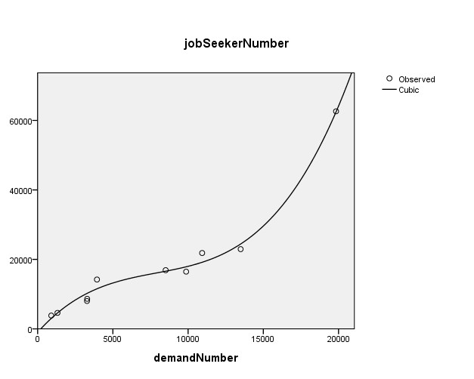
Figure 1 Demand is compared with the number of job seekers simulations of curves
Thus it is that we can be the linear sum , to get the total , followed by the previous model to calculate the profession to meet the needs of both employees and employers .Simply put ,how much should be switched to work for , to make each person has to work .
X=_{i}=x₁+x₂+x₃+x₄+x₅+x₆+x₇+x₈+x₉+x₁₀=180117
Y=_{i}=y₁+y₂+y₃+y₄+y₅+y₆+y₇+y₈+y₉+y₁₀=75377
Each recruit full time work , then the rest of Z = XY = 104740 people do not work , and in the deployment of human resources model, the calculated M = 3.85, that is, a job can mean either directly or indirectly provide 3.85 for the entire company select the position.Thus it can be obtained , if things work that everyone should have exchanged =27,205 people work in order to ensure that employees and employers to meet .

4.2Construction of Markov model
Rational planning of human resources and talent planning and preventive future is a complex social system project , which is closely related to social and economic development , science and technology development , education development , and its importance is self-evident .HR allocation model based on vacancy chains have greatly enhanced the public employment rate.On this basis , the use of Markov model of human resource deployment within the next few years to make predictions .
4.2.1The basic model of Markov
In the Markov model assumes that : in a given time period, the number of high -level shift is the starting time of a fixed proportion of the total number of low-level , this ratio is called the transfer rate from a low level.Once all kinds of numbers , transfer rate, and the number of future supplement given , then the number of various types of future personnel ( coming talent distribution ) can be predicted .therefore:
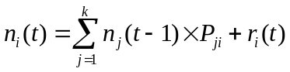 i,j=1,2,3,…,k t=1,2,3,… (6)
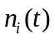:The number of class i at time t
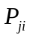:The transfer rate of transfer from the j class to the class I
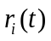:The number at time (t-1, t) in the i class supplement
k :Classification Number.
If i class existence brain drain, we can draw it :
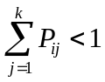 (7)
The ( 1 ) can be rewritten as vector form,definite:
The number of row vector at time t :
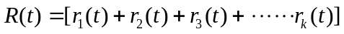
The (t-1, t) in the time number of supplementary row vector:
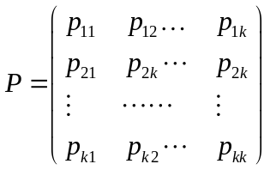
Is the transfer matrix between all types.Thus , ( 1 ) can be rewritten as:
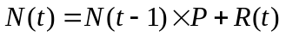，t=1,2,3… （8）
If the value of a given transfer rate , you can get to determine the distribution of future talent , the Markov model can also be called the " advance" model , so that , through the personnel system would enable the staff to a level " advance ."
Markov model established by the above method is deterministic models.Since supplementary personnel loss is promoted in some other uncontrollable and unpredictable , the deterministic model is not practical .Realistic transfer model random,All kinds have a transition probability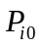,Then i kind of expected value of the total number of transfers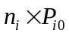.Here is the total number of class i .Thus obtained in (1 ) and ( 2) a similar expression, but this time the predicted value is a statistical expectation .If all of the transfer ( promotion, supplemented loss ) have modeled this method , you can get a description of personnel changes Markov chain model .Completely random or deterministic case only the extreme case , and in fact some random transfer (e.g. loss ) , while others are determined by the transfer ( such as complement , promotion ) .

4.2.2Transition probability is determined
Method to determine the transition probability ( or transfer rate ) depends on the occasion Markov model used .In the deterministic case, since the transfer rate is determined, is a constant , can be observed .However, in the case of random shift is required to estimate the probability of historical data ( such as prior t = - T t = 0 to the time data ) can be an estimate of the probability of metastasis .
Transition probability 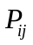 can be estimated
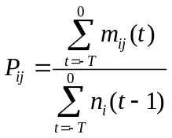 i=1,2,3…,k j=1,2,3…,k (9)
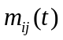 As in (t-1, t) the number of class j within the period of transition from class i
The probability of outflows from class i
In ( 9 ) In the above equation has the same right to transfer if deemed more important in recent years , may be in ( 9) introduced weighting factor。Another method of determining the transfer rate of a similar kind in borrowed talent transfer rate.
Furthermore, the transfer of personnel can be calculated based on the data rate ,Transfer rates of certain staff positions :=Transferred out of the number of staff positions in this category/The class number of the original staff positions ,And can use the transfer matrix or list is given by:
Table7 Personnel transfer list
position |  | Predicted end time
 |  | position1 | position2 | … | positionN
Starting time | position1 | 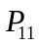 | 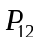 | … | 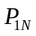
 | position2 | 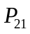 | 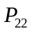 | … | 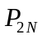
 | … | … | … | … | …
 | Position N | 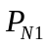 | 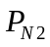 | … | 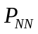
In the personnel transfer list column represents the starting point of the analysis table , rows represent the analysis of the end time .Time interval depends on its human resource planners to select supply forecast , generally for one year.Changes in personnel list cell numbers indicate bear the corresponding row in the first position represents the probability or proportion of employees bear the appropriate column represent positions in the period, the diagonal numbers indicate the end of the period still remain in their original positions the proportion of employees ( retention rate ) .

4.2.3 Determination of Markoff probability matrix
Transition probabilities determined, then the transition probability matrix for each job grade , said transition probability matrix obtained jobs Q={}。
,
Called one-step transition probability matrix , that is, from the second to predict the beginning of the year to personnel changes in the matrix .Called one-step transition probability matrix , that is, from the second to predict the beginning of the year to personnel changes in the matrix .then,
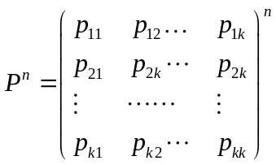,
Called n -step transition probability matrix that personnel changes from the first to predict the beginning of the year n matrix .

4.2.4 To build the model,,to predict
(1)According to historical data of enterprises calculated for each category of each employee positions to Another flow average probability or another level positions.
(2)According to staff positions at every level of the flow of each class of other classes or levels of probability , the establishment of a personnel change in matrix ;
(3)Changes in the organization according to the number of employees at the end of all kinds of positions and step two the number of people predicting the n matrices can be supplied in the organization of X (n).
n=1,2,3… (10)
X(n):The company in various positions initial state vector ;
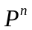: N step transition probability matrix.
4.2.5Human Resources annual cost forecasting model
Human resource costs include recruiting costs, training costs, staff salaries, the cost of various benefits, social security costs and other related expenses.
4.2.5.1Recruitment costs
With the continuous growth of the company 's results of operations and business expansion , the company needs to recruit all kinds of jobs each year staff recruitment fees fundamental to an average of 40 % annually .that is to say:
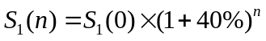 n=1,2,3… （11）
4.2.5.2 Training costs , staff salaries and various benefits expense
With the changes in the human resources , the annual training costs , employee wages and benefits costs and the number of employees of various proportional .that is to say:
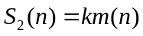 （12）
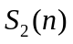:From this date, the first n years of training costs , staff salaries and various benefits costs ;
k:a one-year training costs of employees , average wages and welfare costs , and various ;
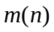:Starting this year, the company was the first n number of employees .
4.2.5.3 Social insurance and other related expenses
With the improvement of our gross national product and the company continues to expand, social insurance and other related costs to an average of 20 % growth .that is to say :
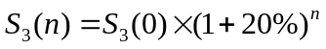 n=1,2,3… (13)
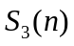:：Starting this year, the first n years of social insurance and other related costs
(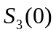 is this year's social security costs and other related needs).

4.2.5.4Total annual cost of human resources
From ( 11 ) ( 12 ) ( 13 ) , we can calculate the total annual cost of human resources :
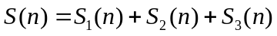
n=1,2,3… (14)
4.2.6 Model analysis and results
The management of an enterprise number is 410 people, in order to facilitate the work carried out , the manager is divided into three levels , namely, senior, intermediate and lower-level managers .On June 12 the number of senior managers , middle managers and lower-level managers were : 30,100,280 ; 13 years in June was 29,150,200 .Also, according to the movement of persons 11-13 years , average. The following table:
Table8 List of flowing layers case managers
project | Senior | middle class | basic level | run off
Senior | 0.65 | 0.05 | 0 | 0.30
middle level | 0.10 | 0.75 | 0.05 | 0.10
basic level | 0 | 0.25 | 0.70 | 0.05

Table 9 June 2012 to June 2013 the annual cost of human resources

expense item | Recruitment | training cost | Staff Salaries | The welfare expenses | The total social insurance | Other related expenses | total
expenses（wan-yuan） | 0.7 | 4.00 | 240 | 27.6 | 63.5 | 8.4 | 344.2

(1) The corporate executives of the initial state vector : X(0)=(30 100 280)
(2)Matrix of transition probabilities in Table 8 build staff
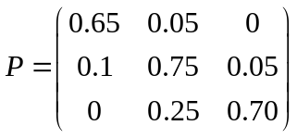
(3)According to the formula ( 10 ) , employees of the state vector obtained using MATLAB 2013-2018 six years ;
X(1) =(30 147 201); X(2) =(34 162 149)；
X(3)=(39 160 112); X(4) =(41 150 87)；
X(5) =(42 136 68); X(6) =(41 121 55);
Figure 2 all levels of management staff mobility trends
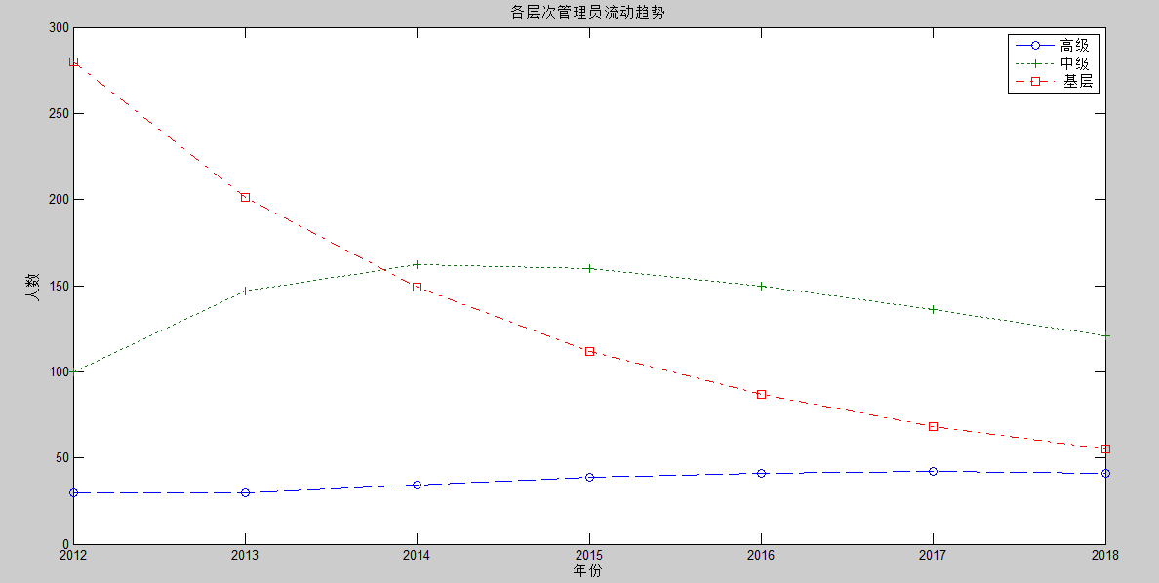

By predicting Markov model , according to the 2012 data to predict 2013 to 2018 data.2013 was 30,147,201 compared to the predicted results with the actual situation , senior, intermediate and primary prediction error was 3.45% , 2% and 0.5 %.Error is less than 5% , this model can be used for prediction. Therefore, in order to 2014-2018 model years of data presumed reliable.
(4)2013-2018 annual budget of HR
According to the table 9:
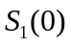=0.7；=0.72;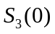=71.9
=335.66
=328.83
=326.32
=328.90
=338.91
S=S(1)+S(2)+S(3)+S(4)+S(5)=1658.62 (wan-yuan)
By Markov model predicted that the company due to the deployment of human resources in the next five years will be spent 16,586,200 yuan .

Ⅴ. Summary
Object model established in this paper is analyzed in the inflow of employees and employee transfers between the various jobs of a business , out of the situation .Human resources are the most valuable resource in order to obtain business development , looking to attract the right people and to the enterprise, is the goal of every business .
HR prediction model based on vacancy chains , but also a good time to predict the company 's personnel changes brought about by the economic benefits.This model not only make their team even better , but also to increase the employment rate of the community.However, this model was in the ordinary operation, the conventional mobility established , there are some factors are not expected to make the prediction model inaccurate .
HR Markov model-based prediction is a more effective and convenient way , in the use and analysis, critical step is to estimate the transition probability matrix . Directly affects the accuracy of the transition probability analysis to predict the outcome , even important decisions affecting the quality .
Solve the problem of forecasting staffing needs , is a more effective and convenient way , in the use and analysis, critical step is to estimate the transition probability matrix .Directly affects the accuracy of the transition probability analysis to predict the outcome , even important decisions affecting the quality . Therefore, this prediction to be further explored and improved.

Ⅵ.References
[1] ZHANG Hong Marcov’s Talent Planning Mode and Its Application
[2] ZHANG Li juan Filtering and a Vacancy ChainsModel in HousingM arket
[3] XHANG Lei Demand forecasting model based on Markov chain personnel

VII. Appendix
Content of Advertisement:
Based on the deployment of human resources vacancy chains can get a job that can provide the entire HR 3.85 jobs ;
The following table shows the data model in Figure II :
sequen-ce number | occupation | Labor force supply and demand
 |  | Demand number | Number of job seekers | Number gap | The requirement rate of the staff
1 | office staff | 19834 | 62623 | -42789 | 0.31
2 | finance and accounting  staff | 10933 | 21842 | -10909 | 0.5
3 | storage  staff | 3942 | 14206 | -10264 | 0.27
4 | Drivers and transport equipment staff | 13495 | 22953 | -9458 | 0.58
5 | Sales staff、 Cashier | 8510 | 16892 | -8382 | 0.5
6 | Computers ( maintenance, operation ) staff | 9871 | 16470 | -6599 | 0.59
7 | Sector Management ( Manager ) staff | 3291 | 8652 | -5361 | 0.38
8 | Security staff | 3280 | 8030 | -4750 | 0.4
9 | Other administrative staff ( clerks ) | 1316 | 4609 | -3293 | 0.28
10 | Farming, forestry, animal husbandry and fishing water production personnel | 905 | 3840 | -2935 | 0.23

Two models have seen a comprehensive model , the data needed to predict one month after the exchange of professional work

sequen-ce number | occupation | Labor force supply and demand
 |  | Demand number | Number of job seekers | Number gap | The requirement rate of the staff
1 | office staff | 20347 | 58166 | -37819 | 0.34
2 | finance and accounting  staff | 11205 | 20547 | -9342 | 0.55
3 | storage  staff | 3842 | 13576 | -9734 | 0.28
4 | Drivers and transport equipment staff | 12123 | 22476 | -9353 | 0.53
5 | Sales staff、 Cashier | 9012 | 16261 | -7249 | 0.55
6 | Computers ( maintenance, operation ) staff | 10123 | 15872 | -5749 | 0.64
7 | Sector Management ( Manager ) staff | 3542 | 8106 | -4564 | 0.44
8 | Security staff | 3592 | 7632 | -4040 | 0.47
9 | Other administrative staff ( clerks ) | 1316 | 3981 | -2665 | 0.33
10 | Farming, forestry, animal husbandry and fishing water production personnel | 1051 | 3652 | -2601 | 0.28

Thus it can be obtained in exchange of a month can improve the employment rate .

